Wispynook Poodles
Dianne Bolognani
1471 King Hill Road
Readsboro VT 05350
Phone: 802-423-7621
critter2me@myfairpoint.net
Debbie Calnan
833 Freezing Hole Drive
Readsboro VT 05350
Phone: 802-423-5155
debcalnan@hughes.net

Wispynook Puppy Sales Agreement and Contract
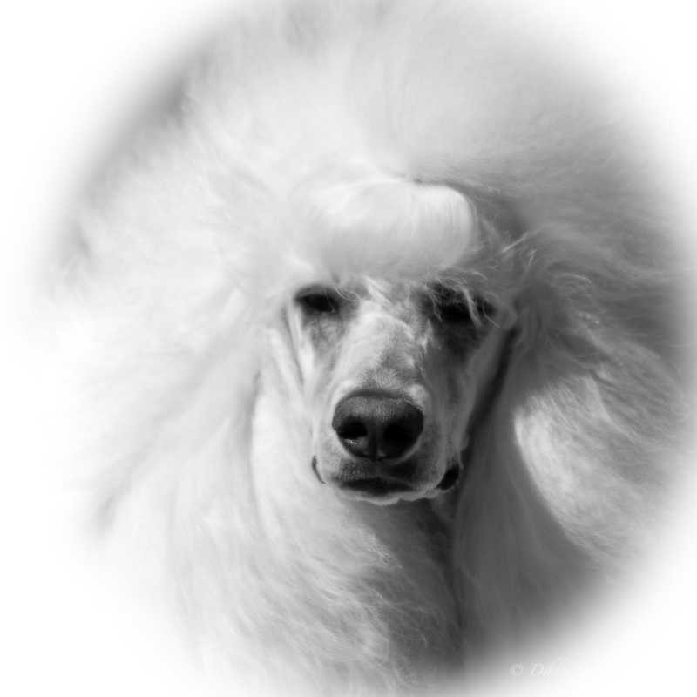
This Agreement made by and between Dianne Bolognani & Debbie Calnan, FKA Wispynook Poodles; be it know that all references to Wispynook Poodles is synonymous with Dianne Bolognani and Debbie Calnan, and (Purchaser) You, is legally binding and properly executed. All further references to ‘you’ in the contract means the purchaser. You and Wispynook Poodles make the following essential and critical warranties to each other:
Congratulations on the beginning of a new relationship which can, will and should be one of unconditional understanding and love between you and your new canine companion!

AKC Registered Name:
Name of puppy/dog: Date of Birth:
Sex: Male Female Intact Neutered Date of sale:
Color and markings: Price of dog:

Shipping cost: $ Deposit given: $
Deposit Payment type: Total owed: $
Final Payment type: Total paid: $
Dam: AKC REG. #:
Sire: AKC REG. #:

Special Terms of sale:
Adopter PRINT NAME:
Seller Signature:
Adopter’s signature:
Adopter’s address:

Adopter’s Phone #: Email:
UNDER NO CIRCUMSTANCES SHOULD ANY WISPYNOOK POODLE BE USED FOR BREEDING WITHOUT PERMISSION FROM WISPYNOOK. ANY PERSON(S) FOUND TO BE USING ONE OF WISPYNOOK POODLES TO MAKE ANY TYPE OF DOODLE, WILL PAY A FINE OF $10,000 AND THE DOG WILL BE RETURNED TO WISPYNOOK POODLES.

Our Commitment To You:
- Puppies are sold with AKC limited registration only unless agreed upon to a show home.

- This puppy is guaranteed to be in good health and properly vaccinated and de-wormed. Wispynook Poodles will provide accurate health records of this puppy. This guarantee is applicable to only the original purchaser for three days.

- Your puppy should be examined by a licensed veterinarian within 72 hours (three days) after being delivered to or picked up by you (breeder not responsible for vet bills). If this puppy is found to have serious life threatening illness or disease (excluding common parasites or coccidian) the breeder will replace the puppy with one of equal value when available. Wispynook Poodles requires that the puppy be returned with documented proof of said illness or disease from a licensed veterinarian within seven (7) days of purchase (breeder not responsible for transportation costs.) Wispynook Poodles reserves the right to have the puppy examined by a licensed veterinarian of its choice to verify diagnosis before replacing the puppy. The contract is null and void if a veterinarian has not been consulted in 72 hours or if the puppy is harmed due to mishandling.

- This puppy is guaranteed to you (the original purchaser) for three (3) years against hereditary and/or genetic diseases. If your puppy is found to have serious hereditary and/or genetic disease, Wispynook Poodles will replace the puppy with one of equal value when available. Documentation of said diseases from a licensed veterinarian is required. Wispynook Poodles reserves the right to have the puppy examined by a licensed veterinarian of its choice to verify diagnosis before replacing. If Wispynook Poodles have no litters planned within one year of date of notification, a refund of purchase price will be given. The option of keeping said puppy or returning him/her to us will be decided individually by Wispynook Poodles. Shipping costs, if applicable, will be your responsibility.

- These puppies do not come trained; however, they will be socialized with other dogs, people and situations and will be accustomed to handling and grooming. We put every effort into starting your puppy off on a solid foundation physically, mentally and emotionally. You MUST spend time with your new poodle to help form him/her into the dog you want it to be.

- Wispynook Poodles uses a limited vaccination protocol. The 2 Way Shot MLV (distemper & parvovirus) will be given at 8 weeks and should be given again at 12 and 16 weeks and again at one (1) year old; and then follow up shots every (3) three years thereafter. Rabies vaccine should be given according to your state’s laws BUT SHOULD NEVER be given on same day as other vaccines, it is best to have four (4) weeks difference between vaccines. Your puppy will have had its 7 week shot at minimum.

- Wispynook Poodles puppies are raised on a combination of raw meat/bones and a good quality kibble.

Your Commitment to Wispynook Poodles:
You represent that no member of your family has ever been charged with cruelty to animals and agree to accept the following conditions and restrictions:

- You confirm that this puppy will be properly housed, fed, watered and exercised and that appropriate veterinary attention will be provided for it if/when required. You further acknowledge that the animal will not be permitted to roam at large or to cause a nuisance to neighbors or those carrying out official duties. When away from home, you will ensure that the dog is kept leashed or under effective verbal control.

- Wispyknook Poodles strongly encourages that the puppy be taken to training/socialization classes. This can only benefit both owner and puppy, enriching the lives of all involved. We strongly encourage that you work your puppy in some type of discipline such as obedience, agility, rally. Any owner who competes in AKC sanctioned disciplines and puts a title on their dog such as an Obedience CD will receive a $50 refund from Wispynook Poodles. This will be a one-time refund.

- We ask that should you have any tests done on this animal such as Hip Dysplasia, Thyroid, von Willebrands Disease, Sebaceous Adenitis or any other tests which could be of interest to Wispynook Poodles that would help us direct our future breeding program, could you please direct a copy of the results to us. No tests are required of your puppy by Wispynook Poodles. All voluntary testing will be undertaken at your cost.

- If, for any reason you cannot keep your puppy/dog, Wispynook Poodles has first right of refusal. You guarantee that the puppy will not be transferred to a third party, without the express permission of Wispynook Poodles in writing. We are here to help you if you need to find a new home for your Wispynook Poodle.

- You agree that if in the future, the terms of this Agreement can no longer be met, or, if you violate any of the provisions of this Agreement, you will surrender custody of your puppy/dog to Wispynook Poodles with NO Refund, Any costs related to the surrender of your puppy/dog to Wispynook Poodles due to your violation of this Agreement, are your sole responsibility.

- You agree that this puppy/dog is being purchased as a pet only. You agree to have this dog altered (spayed or neutered) between the ages of ten months and one year of age. We here at Wispynook Poodles believe that the puppy needs its hormones to help it mature properly. All care should be taken to avoid accidental breeding until alteration can be performed. The AKC registration form will be withheld until the seller receives a statement verifying the alteration from the veterinarian performing the surgery. Limited registration AKC papers are to be provided at that time.

Signed by The Breeder: Dated: / /
Signed by The Buyer: Dated: / /

By signing this contract the Buyer(s) confirm(s) that they have read and agree to all the terms set out within.

